Name
Date _________________ Per __________
BIOTECHNOLOGY WEBQUEST!

INTRODUCTION:
Science involving the understanding and use of DNA has evolved at a revolutionary pace. From the point in which Watson and Crick announced the fundamental double helical structure of DNA, great advances have been made in the application and understanding of this remarkable molecule for all walks of life. Projects such as the Human Genome, transgenic organisms, cloning, genetically modified foods, and crime solving are just some very common and state-of-the art applications of DNA technology today. But with anything new there are ethical/moral, societal, and political questions to be thought over.
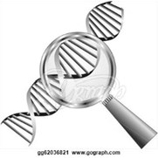
In this activity you will visit 4 webpages and explore some of these exciting and ever-changing topics. Please answer the questions in each section as you work through the webquest / interactive activities.

**HINT: this document is also posted on my webpage, so to reach the URLs, it is easier to open the document on your device, and simply *control-click on the links (instead of trying to type them in!).

A) Gel electrophoresis and DNA fingerprinting

http://www.pbslearningmedia.org/asset/tdc02_int_creatednafp2/

As you work through the simulation, read the information in each step and answer the following questions.
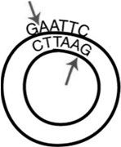
- What is the function of a restriction enzyme? What determines the sites where a restriction enzyme works?

- What is electrophoresis? Why / how does it allow scientists to separate pieces of DNA?

- Why do you have to add radioactive probe DNA? Without the probes, would the DNA show up on the x-ray film?

- Which suspect committed the crime? What did you notice about her DNA?

- Based on the evidence, could any of the other suspects have committed the crime? Why or why not?

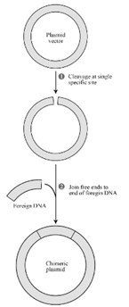
B) Transgenic organisms http://www.pbs.org/wgbh/harvest/engineer/

**Work through the interactive and answer the questions below.

- List three examples of plant foods / crops we humans have altered in some way.

- How did humans first alter crops? What method are scientists using today to change crops?

**Click on “Transgenic Manipulation.” Complete this activity. Read the descriptions of each step as you complete them.

- What is a vector? Why do you think it is possible to take DNA from one organism and successfully put it into another organism?

- What kind of tomato plant resulted from this experiment? How did you know the plant was resistant to the caterpillar?

C) Cloning http://learn.genetics.utah.edu/

*Click on “Cloning”, then on “Click and Clone” to launch the interactive. Work through the interactive and answer the questions below.

- What two cells do you need to isolate to clone a mouse? Did these cells come from the same mouse or different mice?
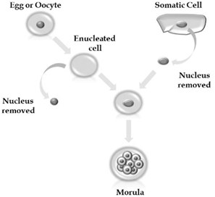

- What is enucleation? What are the blunt and sharp pipettes used for?

- What needs to happen to the new DNA before the process can continue?

- What is the name for a ball of 16 cells? Where do you put this ball of cells after you have grown it?

- What color fur did the baby mouse have? Which mouse’s DNA was it identical to?

- Did this really happen? If so, when and at which university?

D) PCR http://learn.genetics.utah.edu/content/labs/pcr/

**Work through the interactive and answer the questions below.

- What does PCR stand for, and what do we use it for? What are some applications of PCR that are used every day?

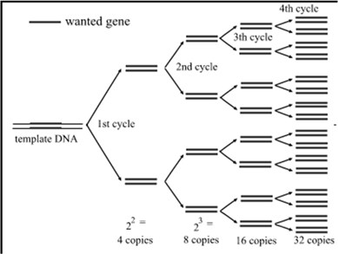

- Roughly how many base pairs are in the human genome?

- What are some sources for the DNA needed to perform PCR?
(HINT: Which body tissues might be used to isolate DNA from?)

- Define these terms and describe the role each plays in PCR.

Term | Definition | Role in PCR
Primer
Nucleotides
DNA polymerase

- How does the thermal cycler work? (Summarize the steps of heating and cooling, including which temperatures are reached, and for what purpose…in other words, what happens at the molecular level during each temperature phase?)

- How many cycles were needed to make over a billion copies of the desired DNA sequence?

