To use this document, first read the Instructions and FAQs. This document is licensed by the Howard Hughes Medical Institute under a Creative Commons Attribution-NonCommercial-ShareAlike 4.0 International license. No rights are granted to use HHMI’s or BioInteractive’s names or logos independent from this document or in any derivative works. Using this document, you agree to use this document in accordance with these terms.

INTRODUCTION
SARS-CoV-2 is a virus that, starting in 2020, has caused the largest global pandemic in recent history. The disease caused by this virus, COVID-19, has affected millions of people worldwide. In this activity, you’ll watch the animation series Biology of SARS-CoV-2 and answer related questions to check your understanding. The concepts you’ll learn will help you better understand COVID-19 and coronaviruses, as well as other viruses and outbreaks in the past, present, and future.

PROCEDURE
There are three animations in this series. Watch each animation, pausing between animations to answer the questions below in the spaces provided.

PART 1: Infection
Watch the first animation, Infection, which shows how SARS-CoV-2 infects and replicates inside human cells.
- Explain how the terms COVID-19, SARS-CoV-2, and coronavirus mean different things.

- The diagram below represents a SARS-CoV-2 virus. In the table below the diagram, identify each of the labeled structures. Write one or two sentences describing the role of each structure in the virus’s replication process.

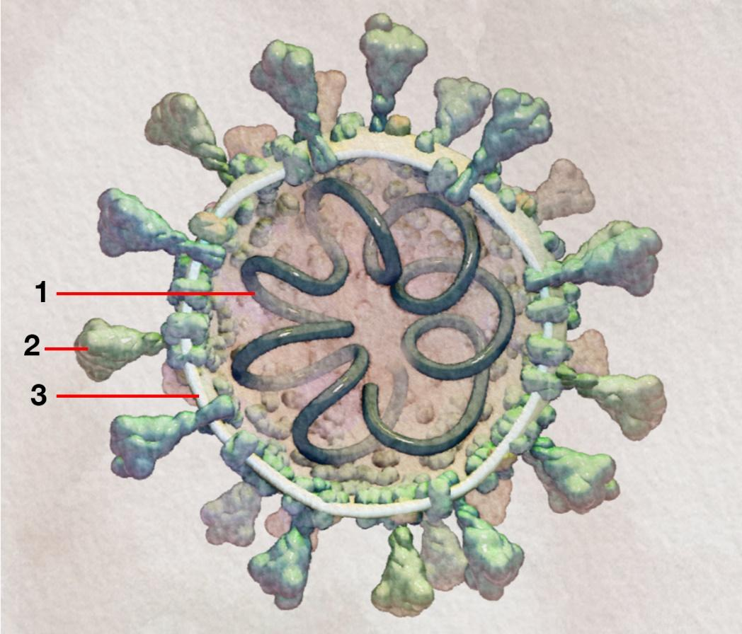
Label | Structure | Role in replication
1
2
3
As shown in the animation, SARS-CoV-2 binds, or attaches, to specific proteins on the surface of a cell. These proteins are called receptors. Scientists have determined that SARS-CoV-2 binds to the same type of receptors on human cells as a different coronavirus that caused an outbreak in 2002–2004 did. That outbreak caused fewer infections and deaths than the SARS-CoV-2 outbreak.
- Scientists discovered that SARS-CoV-2 is 10 to 20 times more likely to bind to these receptors than the other coronavirus was. Predict how this increased chance of binding has affected SARS-CoV-2’s ability to replicate.

- Each of the following statements describes a step in the replication of SARS-CoV-2. These steps are listed in random order. Read through the steps and, in the spaces provided below, list them in the order they occur in the human body.
  - The virus releases its RNA genome into the cell.
  - Viral RNA polymerase helps transcribe more copies of the virus’s RNA.
  - The virus binds to a receptor on a human cell’s membrane.
  - New viruses travel to the cell membrane of the infected cell and are released outside the cell.
  - The virus’s RNA is translated into proteins by the cell’s ribosomes.
Correct order: ___ ___ ___ ___ ___
- As shown in the animation, SARS-CoV-2 uses the ribosomes inside human cells to translate its RNA into viral proteins. According to the animation, what is one of the viral proteins made by the ribosomes, and how does that protein help SARS-CoV-2 make more copies of itself?

PART 2: Evolution
Watch the second animation, Evolution, which shows how SARS-CoV-2 and other viruses may change over time due to mutations.
- The SARS-CoV-2 virus has an RNA genome made of 30,000 nucleotides. List the four different types of nucleotides found in the SARS-CoV-2 genome.

When SARS-CoV-2 replicates, mistakes can be made in some copies of its genome, giving rise to mutations. Mutations happen randomly and are a source of genetic variations, or differences, among viruses.
- Could these mutations make the virus more deadly to humans? Support your answer in one or two sentences.

A common way to prevent infectious viral diseases, such as COVID-19 and the flu, is to develop a vaccine for the virus that causes them. Vaccines can be made from a virus’s proteins or other parts, or from a virus that has been inactivated and is no longer harmful. Some vaccines, such as the flu vaccine, need to be modified every year to keep up with changes in the virus.
Studies have shown that SARS-CoV-2 has a slower mutation rate than the influenza virus, which causes the flu. This means that mutations occur less frequently in SARS-CoV-2’s genome than in the influenza virus’s genome.
- Based on the information above, explain why it may be possible to develop a SARS-CoV-2 vaccine that would not have to be modified as often as the flu vaccine.

Scientists at Arizona State University sequenced SARS-CoV-2 genomes collected from hundreds of infected individuals. They found a deletion of 81 base pairs in some of the viruses. This large deletion is in a gene that codes for a protein that helps the virus escape the immune system.
- Predict how the frequency of viruses with this deletion will change in the population over time. Use evidence to support your answer.

- How could sequencing many SARS-CoV-2 genomes be used to track how the virus has changed over time due to mutations?

PART 3: Detection
Watch the third and final animation, Detection, which shows several ways to test whether someone has been infected by the SARS-CoV-2 virus.
The animation discusses two types of tests used to determine whether someone has an active SARS-CoV-2 infection. The table below compares some aspects of these tests as of August 2020.
Test type | Tests for presence of | Accuracy | Time to get results
RT-PCR test | Pieces of the virus’s RNA genome | Few false negatives.* Test usually does not need to be repeated. | One day to one week
Antigen test | Pieces of viral proteins (antigens) | More false negatives than the RT-PCR test. May need other tests to confirm negative results. | One hour or less
*A false negative is when an active infection is not detected by the test.
- Imagine you are planning to visit a family member who is a nursing home resident. The nursing home requires that all visitors test negative for an active SARS-CoV-2 infection no more than two weeks before the visit. Which of the two tests shown above would you choose, or what other information would you want to learn before choosing? Use evidence from the table to support your answer.

- In addition to the tests described above, people can also get tested for the presence of SARS-CoV-2 antibodies. Explain how an individual could test negative for an active SARS-CoV-2 infection and positive for SARS-CoV-2 antibodies.

